Web Page Development & Design



ID#: 1600219838

Name: Romain Tomlinson

|  |
| --- |
| Information and Communication Technology  Course Title: Web Page Development and Design  Assignment Title: Final Project  Lecturer’s Name: Mrs Lavina Thakur  ID#: 1600219838  Name: Romain Tomlinson  Name of Website Design Company: Codes Factory |

# Team Profile

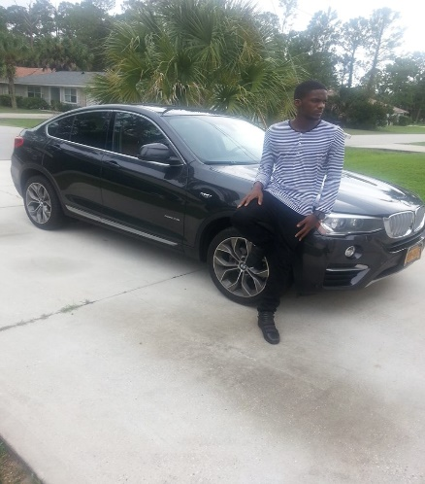Daniel Russell: Young Daniel Russell is heading on the right path to be a web developer, facing personal struggles on the way he has shrugged them off so that he can stay focus and continue on his path to becoming a web developer in the industry.

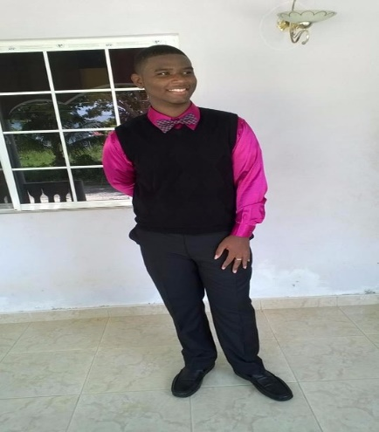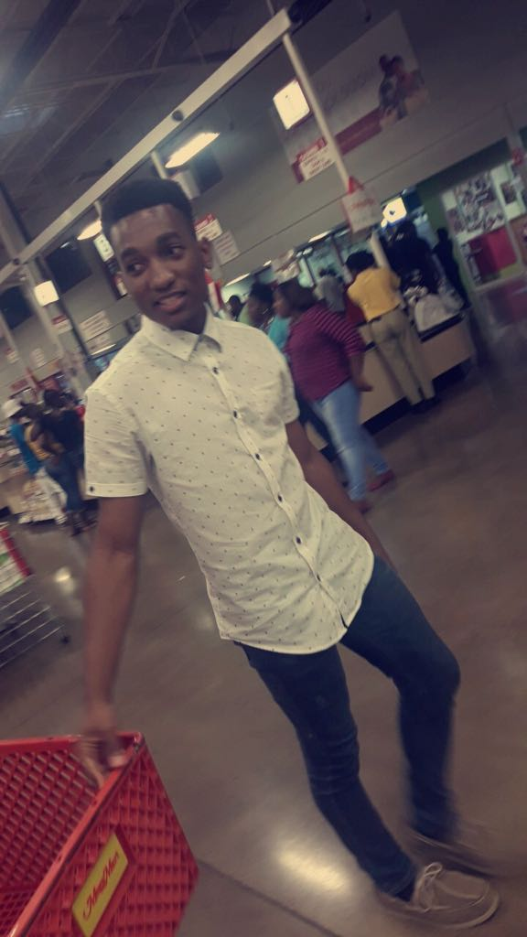

Adrian Smith:

Student of the VTDI institution stationed in Mandeville, Adrian Smith is the chief executive of the editing department responsible for Codes Factory, responsible for the colour scheme and critic of the website basing off of the clients needs. Young Adrian only 18 years of age has already worked his way up to such an impressive rank due to his love for web development and hard work towards it.

Romain Tomlinson:

Diligent and Determined to be the best there is, Romain Tomlinson is the person responsible for many projects leading up to his first big break “Codes Factory”. Romain is used to coding websites and has done majority of the coding for this project using his skills in JavaScript, Html and CSS which he learned at the VTDI institute located in Mandeville. Look out for more from this exciting prospect.

# Client Background

The company Codes Factory has been in existence for a few years now. The company started operation in 2014 due to the vision of the manager, Mr. Romain Tomlinson. Mr. Tomlinson is an entrepreneur at heart and as such wanted his company to display that love by making available cheap gift cards to its customers, ranging from iTunes, Google play, Xbox and Play Station cards. The company is located in shop#5, Santa Cruz, St. Elizabeth. The company is not only about making profit in terms of money but it seeks something more a sense of trust and commitment to the communities surrounding Santa Cruz, the company has allowed numerous individuals to purchase gift cards at retail prices which they have used for promotional services as well as towards donations within the surrounding communities.

# Purpose of site

The Company has realized that they need a way to make their products more marketable and in essence their company. Mr. Tomlinson realized that this is the age of technology and sees the internet as an avenue to market his company so he decided to get a website built for his company.

The purpose of this website is to:

* To let persons worldwide know about the company.
* Advertise their products both locally and internationally.
* Increase the number of customer.
* Increase the number of partners.

# Story Board- Home Page

Logo

Navigation

Images slideshow

Products

Footer

Sponsor site

Categories

## Wireframe

# 

# Mock-ups

# Site features

The Codes Factory website will feature:

An attractive home with animations that will allow the user to navigate to the other supporting pages. The home page will also have a table beneath showing the categories for the various products as well as a table showing a few of the products available as well as a link to our sponsor site.

An Xbox gift cards page that will show the Xbox cards available as well as the prices and pictures of the cards.

A Play station gift cards page that will show the play station cards available as well as the prices and pictures of the cards.

A Google play gift cards page that will show the google play cards available as well as the prices and pictures of the cards.

An iTunes gift cards page that will show the iTunes cards available as well as the prices and pictures of the cards.

A login page that allows the user to sign in before ordering items.

The website has a white background to provide better readability.

A contact us page that contains a form that allows the user to send feedbacks and comments to the company.

A thank you page that displays after the user clicks the send button on the contact page that has a message and a picture displayed.

**Colour Scheme/Justification**

The website’s colour scheme is grey within the navigation bar and footer with a white background, this scheme is present throughout all webpages apart from the login page which has an image as the background. The texts are in white and within some pages it is blue, green and grey due to the background colour that was used.

# Site Map

**Home Page**

**login Page**

**Cart**

**Sponsor site**

**Xbox page**

**Google play page**

**Play station page**

**iTunes page**

**Contact page**

Email received page

# Client Questionnaire

1. What is the name of the business? _____________________________
2. Where is the business located?
   1. St. Elizabeth
   2. Manchester
   3. Kingston
   4. Other
3. How long has the business been in operation?
   1. 1 years
   2. 3 years
   3. Less than a year
   4. Over 3 years
4. Do you have a logo?
   1. Yes
   2. No
5. Does your business have any brand colours or do you want a colour to be put in place to represent the company? Please indicate on the line. ____________________________________________

______________________________________________________________________________

1. Please state your mission and vision statement.
   1. Mission Statement:_______________________________________________________________________________________________________________________________________________________________________________________________________________________________________________________________________________________
   2. Vision Statement:_______________________________________________________________________________________________________________________________________________________________________________________________________________________________________________________________________________________________________________________________________________________________
2. Please state the products or services that your business offers.

__________________________________________________________________________________________________________________________________________________________________________________________________________________________________________________________________________________________________________________________________________________________________________________________________

1. Who are your targeted customers in terms of age?
   1. Adult only
   2. Children only
   3. Teenagers only
   4. All of the above
2. Do persons have to have a certain level of education to benefit from your business?
   1. Yes
   2. No
3. Do persons have to live in a certain region to be your customer?
   1. No
   2. Yes
4. What problems do you face with the business? _________________________________
5. Do you believe a website will solve those problems?
   1. Yes
   2. No
6. Have you ever had a website before?
   1. Yes
   2. No
7. If your answer to question 10 is yes write the URL of that website on the line provided.

____________________________________________________________________

1. What is the URL that you want your new website to have?

____________________________________________________________________

1. How many webpages should your website contain?

___________________________________________________

1. What products or services should be available on the website?

_______________________________________________________________________________________________________________________________________________________________________________________________________________________________________________________________________________________________________________________

1. What features should the website contain?

________________________________________________________________________________________________________________________________________________________________________________________________________________________________________________________________________________________________________________________

1. Will you require your products/services to be updated on the website?
   1. Yes
   2. No
2. If yes how many times per month do you expect to update the website?
   1. Once per month
   2. 2 times per month
   3. 3 times per month
   4. Anytime new stocks are available
3. Would you and your staff have the knowledge base to make the updates?
   1. Yes
   2. No
4. Would you prefer I (the developer) to update the website whenever the need arises?
   1. Yes
   2. No

## Information Architecture

Home

Login

Cart

Xbox gift cards

Play station cards

Google play gift cards

iTunes gift cards

Contact us

iTunes cards product page

Xbox cards product page

Play station cards product page

Contact form page

Google play cards product page

Email received page

Footer

Sponsor site

## Screenshots

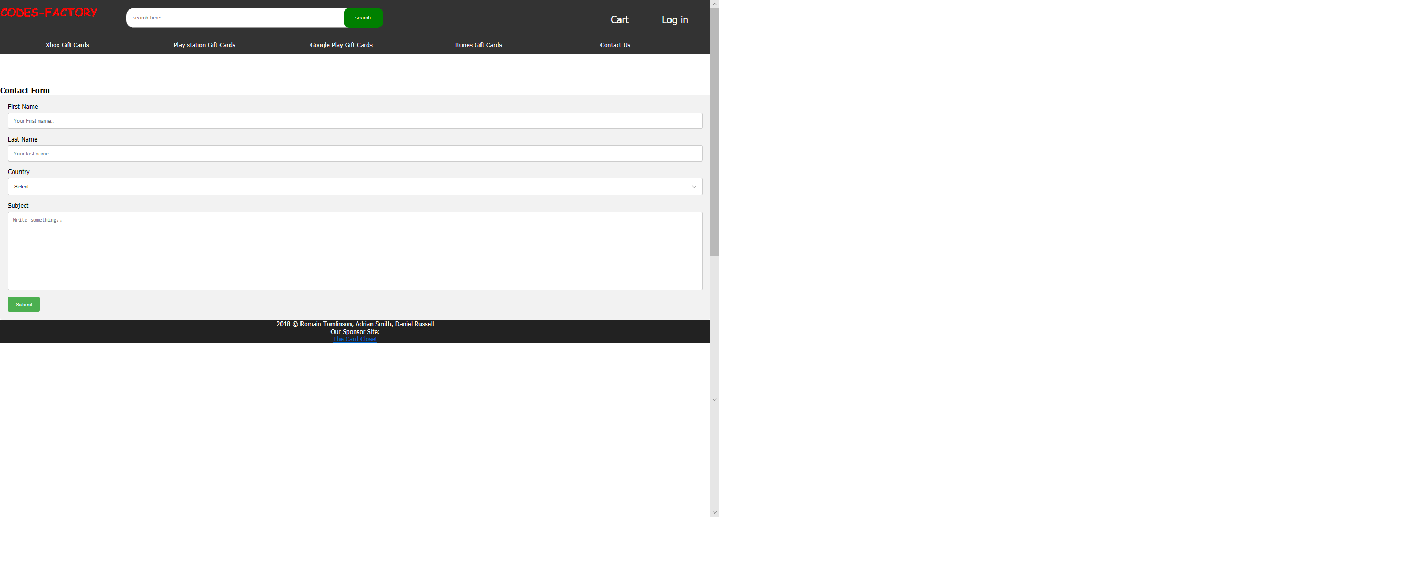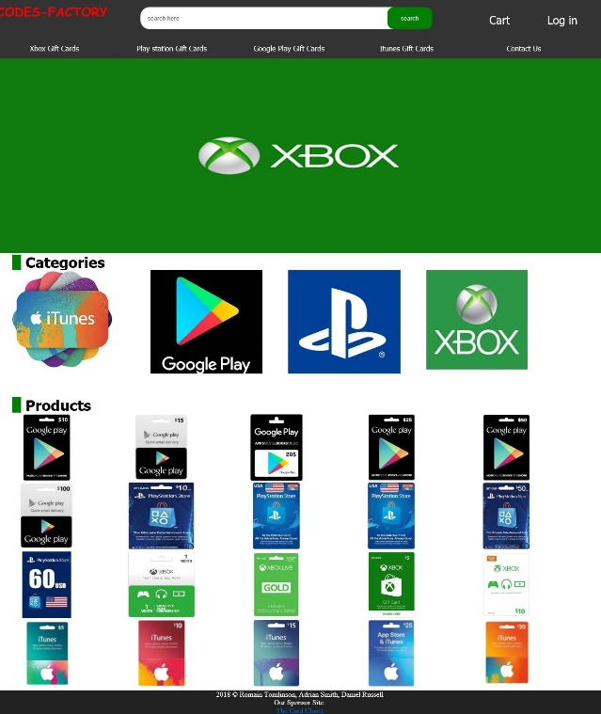

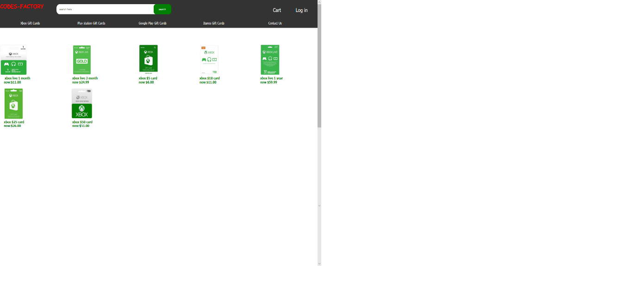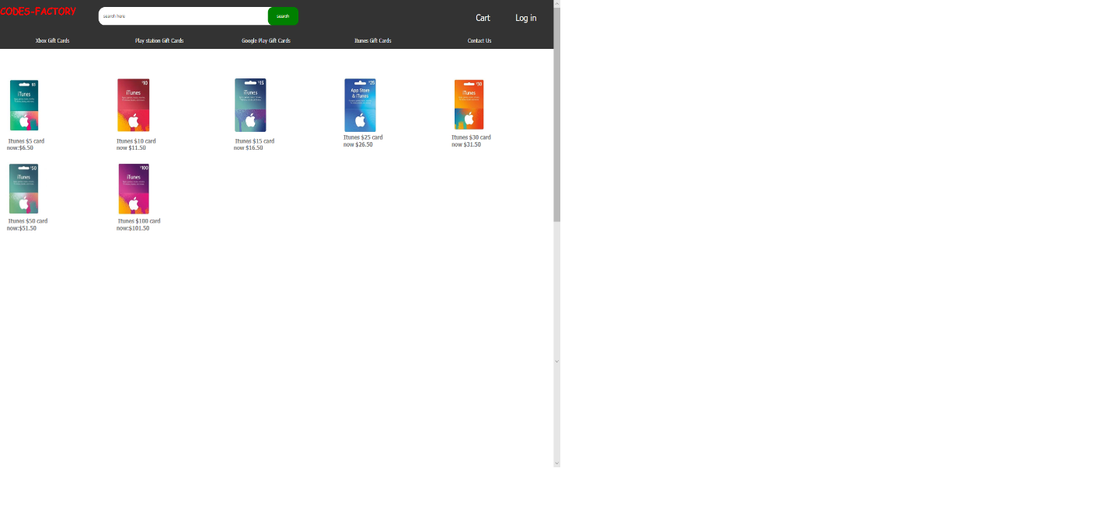

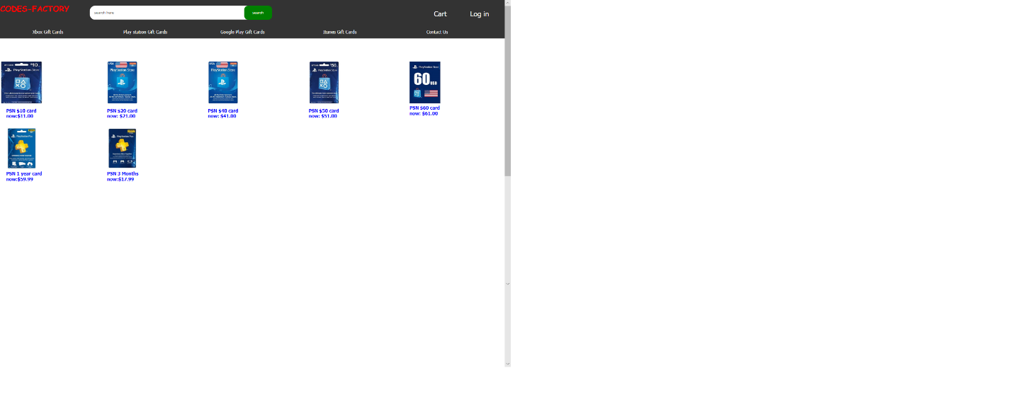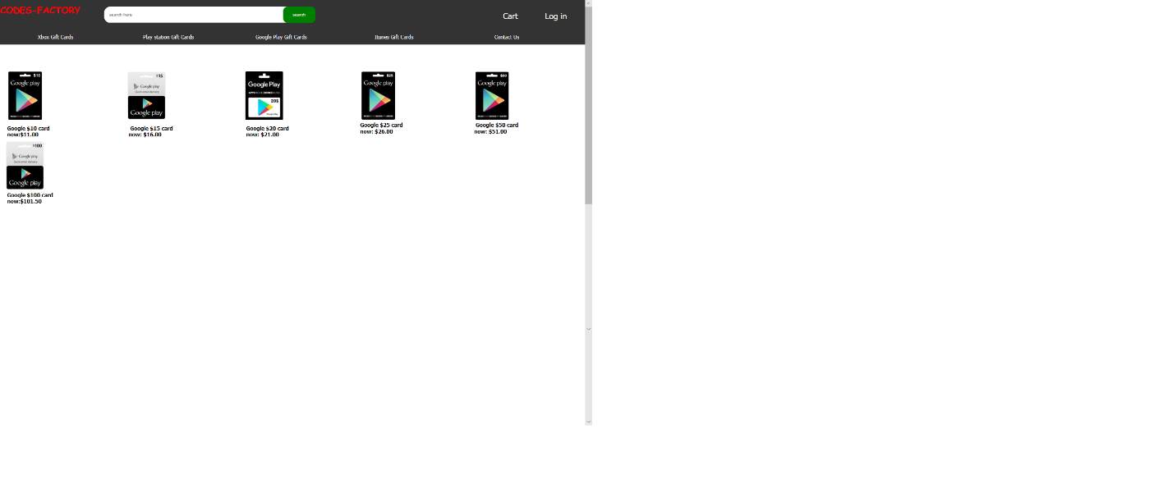

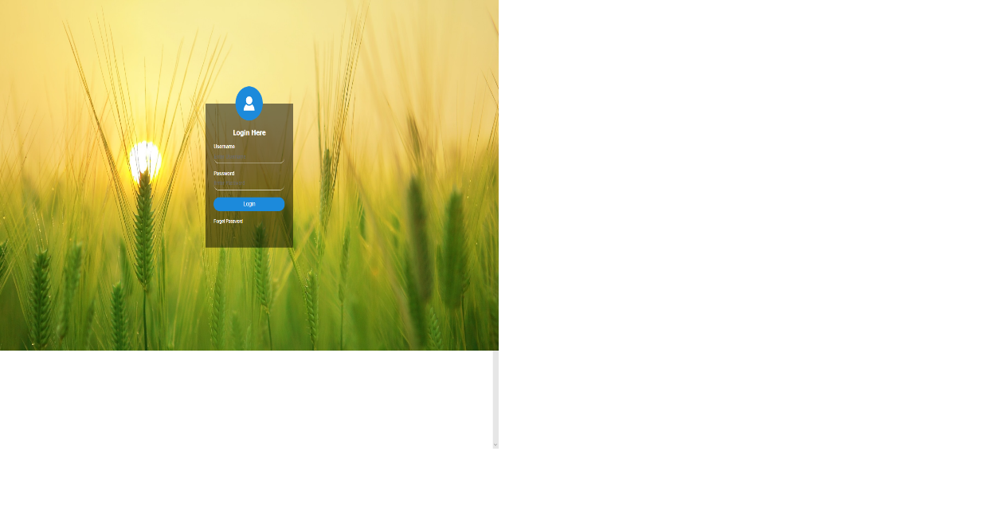

## Individual Critique

(Romain Tomlinson)

In completing this website, my role was to do the coding and design of the web pages with the use of Html, CSS and JavaScript as well as various sections of the documentation. The challenge I faced was trying to utilize JavaScript and getting an understanding of the language to create the slideshow within the homepage. I learnt that trial and errors had to be experienced to get the tasks done to my team’s expectations. Overall, my group members helped in whatever way they could and a little more effort would’ve been appreciated from them. However, I think that overtime this website can be improved as we are still learning and as we go along we can implement what was learnt.

(Adrian Smith)

The Completion of this website didn’t take much thinking about if I’m honest, for the ideas were already put in place to work upon. Though challenges were indeed faced in terms of getting the art work, look and feel and completion to be ready by the due date, everything ended up fine even though things had to be sacrificed in the process to achieve said goal. My job was to create the forms, allocate pictures and create a few images using photo shop for the slides. I was also responsible for checking over the website so that it runs smoothly, looks nice and would be marketable for use. The most erotic challenge faced for this entire project was the compatibility with other browsers. There is always room for improvement and mistakes are gateways to a better understanding of something so regardless of this formidable challenge of web development we, the group members gave it our all.

(Daniel Russell)

Although we had an idea of how we wanted the website to be created and how to present it to our audience. We came across challenges while creating it. for me personally the documentation was bit of a challenge and am proud to say that I overcame that challenge and by overcoming that challenge my love for the website grew. Now my job was to get the pictures for the website and I also came up with the idea to make PlayStation gift cards in our website and to look back over the website when it was finished to ensure that everything that we had planned out was in the website. I also want to thank Mrs Thakur for this challenge reason for saying this is because the love that I have for the website increased significantly.